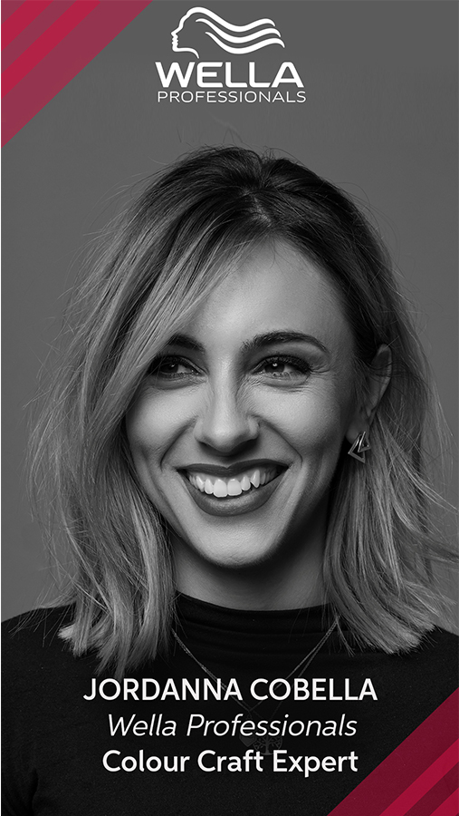
Jordanna Cobella is a London based Hairstylist with an established business in the heart of west london, Cobella Kensington. Recently nominated for London Hairdresser of the Year for 2 consecutive years running, her expertise in colour and styling is industry recognised. As a Wella UK Guest Artist & Craft Expert for UK and Ireland, she is behind the latest colour campaigns and colour trends for British Hairdressing. She has worked at London, Paris and Milan Fashion week for the last 7 years and has a wealth of experience in session hair including editorial work, TV & Film.

Her passion for connecting with people has lead her to write and publish her own book this year, 'The Mindful Hairdresser' which explores the emotional intelligence side of the hairdressing profession.

Educational Roles
Jordanna not only educates in the UK on behalf of GHD, the Fellowship, Cobella and the Foster Academy but also educates abroad. Being invited as a guest artist to appear in Russia, Madrid, Milan and Bologna to deliver dynamic creative cutting and styling knowledge as well as revealing the trends that inspire Britain. She is a natural educator and enjoys sharing her knowledge to enough to a wide variety of audiences. She also proudly holds the title most recently as a Wella Professional Colour Craft Expert for UK and Ireland endorsing the brand and working collaboratively on exciting events and projects.
Editorial & Fashion Work
Jordanna has assisted the likes of Eugene Souleiman, Brendon O’Sullivan, Richard Phillipart and Charlie Le Mindu on fashion week in London, Paris and Milan. She regularly shoots for magazines and her work has been published in Harpers Bazaar Kazakhstan, Dreamingless Magazine, Overdue Magazine and Mod Magazine.
Awards and Accolades
Jordanna has a hunger for education, training and success. Part of her passion derives from her industry peers who have encouraged her to enter competitions and inspire her to learn from all industry figureheads. As a result of this, she has achieved the following;

- Fame Team Member 2017
- Loreal Colour Trophy Regional Finalist 2015
- Loreal Colour Trophy Regional Finalist 2016
- Loreal Colour Trophy Regional Finalist 2017
- Fashionista Award at Hair Club Live 2016
- Hair Club Live Think Tank Member
- Selective Professional International Guest Artist 2017
- GHD Brand Warrior 2018
- Wella Passionista 2018
- Joewelle Scissors International Guest Artist
- IT Girl Finalist 2018
- IT Girl Finalist 2019
- IT Girl Finalist 2020
- London Hairdresser of the Year Finalist 2019
- London Hairdresser of the Year Finalist 2020

For PR enquiries, please contact Dawn Driscoll PR at dawn@dawndriscollpr.co.uk

